# Motivation

Renewable Energy Sources (RES) are playing an increasing role in global energy consumption. Governments are introducing policies to bolster RES as the human civilization is looking for an effective solution to climate change (The World Bank, n.d.). Traditional fossil-fuel based energy systems have centralized generation. The fuel supply, hence, the generation can be controlled until the resource is exhausted. In contrast, RES rely on perpetual resources of water, solar radiation and wind. However, the intermittent nature of these resources pose additional challenge as electricity supply must meet demand at any instant.

Among the RES, hydropower accounts for a bulk of electricity production ( $60 \%$ in 2018 (REN 21, 2019). Hydropower systems can be broadly divided into reservoir-based (storage) or run-of-river. Both forms of hydropower rely on precipitation in the catchment area of the reservoir/weir for their operation. Ideally, a reservoir-based hydropower operator desires to have high water levels to maximize power generation, but it needs to be prepared for an increase in water level due to future precipitation event. Hence, information in future rainfall, which gives information on future reservoir inflow, is essential for efficient reservoir operation (Doug McCollor & Stull, 2008a). Since traditional run-of-river projects do not have additional flow control capabilities other than the weir, future inflow information seems redundant. However, short range (1-2 days) information on power generation helps the utility plan its resources to match demand and supply. Furthermore, the generators could use this information to make profitable bids in a competitive electricity market.

Weather forecasts using Numerical Weather Prediction (NWP) can be used to estimate future inflow information. NWP models can forecast precipitation over a watershed. The forecasted precipitation is used as one of the inputs for hydrologic model, which provides inflow information for the hydropower system. Province of British Columbia (BC) and Nepal both rely heavily on hydroelectricity. Nepal generates 94% of its energy from hydropower, predominantly through run-of-river projects. The figure is 90% for British Columbia, mainly through storage-based systems. Hence, numerical precipitation forecasts can benefit both the regions. NWP forecasts have been actively used by BC Hydro for operational decision making (D. McCollor, 2004). However, its applications have been limited to storage-based systems only. On the other hand, NWP has not been implemented for applications in the energy sector in Nepal.

# Research Question

The adoption of NWP for run-of-river in both regions will depend on the accuracy of the forecasts and the associated economic aspects. The purpose of the thesis is to answer questions in these two thematic areas:

1. How reliable are the NWP forecasts for Nepal and BC?
2. What is the economic value of the forecasts for a decision maker?

# Literature Review

## Numerical Weather Prediction - Introduction

Numerical weather prediction involves solving the equations of fluid dynamics for air. These equations, also known as the equations of motion, are based on the fundamental laws concerning momentum conservation (Newton’s 2nd law), energy conservation (1st law of thermodynamics), mass conservation (continuity equation), moisture conservation and the ideal gas law (Warner, 2010). These equations form a system of non-linear coupled partial differential equations, which do not have an analytic solution, except for the most simplified cases (Stull, 2017). These equations can be solved using different *numerical methods*[1], which has given rise to the different NWP models that are in use today.

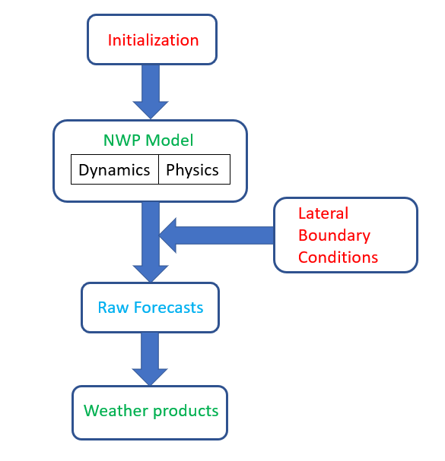

Figure 1: NWP forecast process. Final step weather products include probabilistic forecasts, weather charts or meteograms (Source: own illustration based on (Warner, 2010)

The equations of motion are formulated by considering atmosphere as a continuous, compressible fluid (Tribbia, 1997). The continuous field has to be *discretized* so that it can be stored in a computer’s memory. Hence, a region of forecast is divided into smaller volumes called grid cells. Some of the atmospheric processes are either too complicated to solve exactly for each grid cell, or are much smaller in scale than a grid cell. These net resolvable effects of these unresolved processes, including cloud and precipitation processes, must be *parameterized*. The parameterized sub-grid scale processes in NWP models are also referred to as *physics*. The variables, and the associated processes that can be resolved on the grid scale comprise of model *dynamics* (Stull, 2017). These are variables such as temperature, humidity and they are solved using the fundamental forecast equations.

Solving a system of partial differential equations requires initial and boundary conditions. The initial condition is the ‘present’ state of the atmosphere, after which we are seeking a forecast. Ideally, the initial state is captured through the weather instruments such as radars and radiosondes (for upper-atmosphere measurements). However, the weather stations are not equally dispersed, and they are not in the exact locations as the simulation grid points. So, the observations are interpolated to desired locations and remaining data gaps are filled using previous forecast. This process, *analysis*, is used as initial condition in NWP models. The boundary conditions would be at the top of the modeled atmosphere, and at the earth’s surface for *global models*. *Limited Area Models* require lateral boundary conditions in addition to the upper and lower boundary conditions.

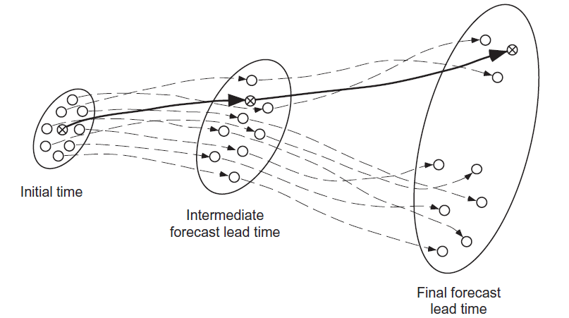

Figure 2: The concept of ensemble forecasting. The circular regions denote all the possible states of the atmosphere. Note the small circle at initial time. Even the initial state cannot be exactly determined due to measurement errors and inadequate distribution of measurement devices. A single weather model run (solid black line) would have given one possible state of the atmosphere, which could be very inaccurate. Hence, having multiple members (dotted lines), i.e., forecast combinations, allows us to capture the possible states of atmosphere more accurately. If majority of the members converge towards a particular state (region within the oval), then the forecast has higher predictability. [from (Wilks, 2020)]

Final step in an NWP model run is called *post-processing*. It involves additional processes to minimize the random and the systematic errors. The bias-corrected forecasts are then used to produce weather maps and charts. Forecasts are verified with measured observations for their quality. Statistical methods such as Kalman filters and Model Output Statistics (MOS) are used to minimize systematic errors (Warner, 2010). Random errors can be reduced by using an ensemble approach. *Ensemble forecasting* involves running NWP models for the same period, but with different conditions such as different grid resolution, initial conditions or parameterizations. Ensemble forecasts are calibrated to give *probabilistic forecasts*, which allow user to make decisions under uncertainty (e.g. 10% chance that the precipitation will be below 5 mm) (Stull, 2017).

## Ensemble Forecasting

An ensemble mean is, on average, more skilful than a single deterministic forecast (Sene, 2016). A multi-model ensemble has been known to outperform an ensemble with variations of a single model. Higher resolution models are desirable for precipitation forecasts as they can capture the orographic effects due to complex terrain. However, forecasts in complex terrain such as the mountains of British Columbia and Nepal benefit from addition of coarse resolution NWP models in an ensemble. (Doug McCollor & Stull, 2008a). Accordingly, different forecast centres have adopted these findings in their operational forecasting operations. The concept of ensemble forecasting has been further extended to ensemble streamflow forecasts that incorporate ensemble precipitation forecasts with hydrology models (Boucher & Ramos, 2018) (Sene, 2016)(Bourdin & Stull 2013; Bourdin et al 2014).

Forecast quality is an important determinant of the value of forecasts, which determines the usefulness of weather forecasts (R. W. Katz & Murphy, 1997). Forecast *verification* is the process of assessing forecast quality by quantifying the relationship between forecast(s) and corresponding observation(s) using statistical approaches. (Murphy, 1997) breaks down forecast quality into ten aspects. The importance of each of these forecast quality aspects has led to the use of more than one forecast verification measures in the meteorology community. (Wilks, 2020) describes commonly used approaches for forecast verification. Most of these techniques were used to verify precipitation forecasts across different locations in British Columbia in (Doug McCollor & Stull, 2008a).

## NWP in Nepal

NWP in Nepal is relatively young, with the operational forecasts having started in 2015 (Meteorological Forecasting Division, 2018). NWP research activities have been mainly based on the Weather Research and Forecasting (WRF) model. Besides precipitation, NWP research in Nepal have covered topics such as wind resource assessment (Regmi & Maharjan, 2013), aviation (Regmi, 2015) and moisture flow (Acharya et al., 2015). Maharjan & Regmi, (2015) simulated a record high precipitation event on the foothills of the Himalayas using WRF and compared it with rain gauge measurements. Shrestha et. al., (2017) performed WRF runs using 4 different bulk microphysics parameterization schemes, where they tried to simulate a convective storm event that occurred in 2011 at Nagarkot, a town in Nepal. While most of the works have focused on simulating a historical precipitation event across different locations in the country, none of the works have investigated the various aspects of quality of forecasts as presented by (Murphy, 1997).

## Value of Weather Forecasts

The economic justifications to produce weather forecasts and associated products have led to various approaches. One particular approach is to perform impact assessment studies of a high-impact weather event (e.g. typhoon) and evaluate the amount of losses that could be avoided if it was forecasted and essential early warning measures were implemented. Another method is to evaluate the value of the weather forecast information. Johnson & Holt (1997) highlight two different aspects: i) value of weather information to individual decision makers and ii) value of weather information at the market level.

For an individual decision maker such as hydropower operator or grid utility, the most common value assessment approach has been the cost-loss (C/L) scenario (Murphy, 1976). This was implemented by (Doug McCollor & Stull, 2008b) to evaluate the economic value of forecasts for hydroelectric reservoir operators. They found that different users require different precipitation forecast probabilities, which would trigger them to take protective action. The triggering precipitation probability depends on a hydro operator’s C/L ratio, which in turn depends on factors such as reservoir dimensions, or presence of other reservoirs upstream/downstream.

# Methods

## Watershed Identification

The first step in the research will be identifying a watershed of interest. Ideally, the subject watershed would have the following characteristics:

1. It houses a major run-of-river project or multiple run-of-river projects.
2. Availability of ground-based precipitation measurement stations

For British Columbia, there is a list of IPP projects with whom BC Hydro have an Electricity Purchase Agreement (EPA) (BC Hydro, 2020). Similarly, for Nepal the Department of Electricity Development has a list of hydropower projects, which have received a generation license (Department of Electricity Development, 2020). A possible approach is to plot the run of river projects in a map and identify possible site of interest.

## Weather Forecast Models

The Weather Forecast Research Team (WFRT) led by Dr. Roland Stull at the University of British Columbia runs ensemble forecasts at four initialization times 0000, 0600, 1200 and 1800 UTC. The UBC ensemble consists of four models:

1. WRF Advanced Research core (WRF-ARW),
2. WRF Nonhydrostatic Mesoscale Model (WRF-NMM),
3. Fifth-Generation Penn State/NCAR Mesoscale Model (MM5)
4. Model for Prediction Across Scales (MPAS)

These models are run at nine different grid lengths ranging from 1.3 km to 108 km. Further ensemble members are created by using six initial conditions from five different weather agencies around the world. The forecast domain covers entirety of British Columbia. So, the main task for British Columbia will be to interpolate the gridded forecasts to the region where the watersheds are located.

The operational forecasts run by the Nepali meteorology department runs at grid size of 12 km and 4 km (Meteorological Forecasting Division, 2018). There are global models such as the North American Ensemble Forecast System (NAEFS), which cover Nepal as well. Furthermore, the regional model run by the Indian meteorology office also covers Nepal. However, I still need to investigate if and how I can get access to the data from the different sources. Finally, to have high resolution output in the ensemble, I have the capability to make WRF runs over the basin of interest using a small grid size that can better capture the small-scale convective processes (e.g. thunderstorms) that can cause heavy localized rain in the mountains.

## Ground based measurements

Details on surface measurement stations across Canada are available through the meteorological station catalogue (Environment and Climate Change Canada, n.d.). Similarly, DHM – Nepal has an online database of the meteorological stations across Nepal (Department of Hydrology and Meteorology, n.d.). The next step would be to check the availability of the weather stations and recorded data in the regions of interest.

## Economic value

Both Nepal and BC have vertically integrated utility. Furthermore, the electricity trade between power producers and the utility is through Feed-in tariffs (FiTs) in both regions. In this scenario, the inflow forecasts do not add value to the plant operators as flow control measures are limited. The only possible benefactor is the utility, who can use the future inflow information to better optimize the hydro facilities. An example would be to maximize use of run-of-river operations and save water in storage facilities, which can be later used to trade at higher prices or meet peak demand.

Further research can be done to evaluate the value in multiple scenarios:

1. Introduction of Peaking Run-of-River (PRoR) projects

PRoR is a newly trending concept in Nepali energy industry. Such plants have storage capacity of a few hours. So, they can run in full capacity during the peak demand, where they get paid more as well.

1. Implementation of bidding market

FiT is a common approach towards subsidizing renewable energy. However, there are many markets which employ day-ahead bidding. Research can be done on how the economic value of forecasts would change of both jurisdictions implemented the day-ahead bidding for energy.

The two scenarios are preliminary ideas. A good understanding of energy markets would be required for both these scenarios. I need to do further research to understand the prerequisites that would be needed to explore these scenarios.

# Future work

For the final part of this proposal, I have listed my tasks for the summer term 2020:

1. Select a watershed of interest in each country, based on the criteria stated in Section 4.
2. Learn how data can be accessed from the UBC ensemble.
3. Learn the techniques required to interpolate forecasts to regions of interest .
4. Investigate how to gain weather-station data and NWP data from Nepal.
5. Investigate the specifications (run times, availability, grid resolution) for global/regional models that cover Nepal, and make my own high-res WRF runs if needed.
6. Check the availability of ground-based precipitation stations in British Columbia.
7. Strengthen my economics background.
8. Research more on the energy markets and renewable energy-meteorology nexus.
9. Go through the Hydropower

# Acknowledgements

The primary funding for this work has been through a MITACS funding in partnership with BC Hydro.

# References

Acharya, S., Neupane, S., Shrestha, R., Chapagain, C., Acharya, P., Maharjan, S., & Regmi, R. (2015). Early Monsoon Time Local Flow Characteristics over the Hetauda Valley and its Implications. *Journal of Institute of Science and Technology*, *19*(2), 109–117. https://doi.org/10.3126/jist.v19i2.13863

BC Hydro. (2020). Independent Power Producer (IPP) Supply List - In Operation. Retrieved May 24, 2020, from https://www.bchydro.com/content/dam/BCHydro/customer-portal/documents/corporate/independent-power-producers-calls-for-power/independent-power-producers/ipp-supply-list-in-operation-20200401.pdf

Boucher, M.-A., & Ramos, M.-H. (2018). Ensemble Streamflow Forecasts for Hydropower Systems. *Handbook of Hydrometeorological Ensemble Forecasting*, 1–19. https://doi.org/10.1007/978-3-642-40457-3_54-1

[Bourdin, D. and R. Stull, 2013: Bias-corrected short-range member-to-member ensemble forecasts of reservoir inflow.  J. Hydrology, 502, 77-88. http://dx.doi.org/10.1016/j.jhydrol.2013.08.028](https://tawhiri.eos.ubc.ca/research/publications/journals/94-2013) .

[Bourdin, D., T. Nipen and R. Stull, 2014 (April): Reliable probabilistic forecasts from an ensemble reservoir inflow forecasting system. AGU Water Resources Research, 50, 3108-3130. doi:10.1002/2014WR015462](https://tawhiri.eos.ubc.ca/research/publications/journals/96-2014) .

Department of Electricity Development. (2020). Issued Generation License :: Hydro. Retrieved May 25, 2020, from https://www.doed.gov.np/license/21

Department of Hydrology and Meteorology. (n.d.). Meteorological Station. Retrieved May 25, 2020, from http://dhm.gov.np/meteorological-station/

Environment and Climate Change Canada. (n.d.). Meteorological Station Catalogue - Open Government Portal. Retrieved May 25, 2020, from https://open.canada.ca/data/en/dataset/9764d6c6-3044-450c-ac5a-383cedbfef17

Johnson, S. R., & Holt, M. T. (1997). The Value of Weather Information. In R. W. Katz & A. H. Murphy (Eds.), *Economic Value of Weather And Climate Forecasts* (pp. 75–108). https://doi.org/10.1017/cbo9780511608278

Katz, R. W., & Murphy, A. H. (Eds.). (1997). *Economic Value of Weather and Climate Forecasts*. https://doi.org/10.1017/cbo9780511608278

Maharjan, S., & Regmi, R. R. (2015). Numerical Prediction of Extreme Precipitation over a Truly Complex Terrain of Nepal Himalaya. *Journal of Institute of Science and Technology*, *20*(1), 15–19. https://doi.org/10.3126/jist.v20i1.13905

McCollor, D. (2004). Overview of Hydrometeorologic Forecasting Procedures at BC Hydro. *AGUFM*, *2004*, H21H-05.

McCollor, Doug, & Stull, R. (2008a). Hydrometeorological short-range ensemble forecasts in complex terrain. Part I: Meteorological evaluation. *Weather and Forecasting*, *23*(4), 533–556. https://doi.org/10.1175/2008WAF2007063.1

McCollor, Doug, & Stull, R. (2008b). Hydrometeorological short-range ensemble forecasts in complex terrain. Part II: Economic evaluation. *Weather and Forecasting*, *23*(4), 557–574. https://doi.org/10.1175/2007WAF2007064.1

Meteorological Forecasting Division. (2018). Numerical Weather Output -. Retrieved May 20, 2020, from http://www.mfd.gov.np/nwp/#/nwp/Model

Murphy, A. H. (1976). Decision-Making Models in the Cost-Loss Ratio Situation and Measures of the Value of Probability Forecasts. *Monthly Weather Review*, Vol. 104, pp. 1058–1065. https://doi.org/10.1175/1520-0493(1976)104<1058:dmmitc>2.0.co;2

Murphy, A. H. (1997). Forecast Verification. In R. W. Katz & A. H. Murphy (Eds.), *Economic Value of Weather And Climate Forecasts* (pp. 19–74). https://doi.org/10.1017/cbo9780511608278

Regmi, R. P. (2015). Aviation Hazards in the Sky over Thada as Revealed by Meso-scale Meteorological Modeling. *Journal of Institute of Science and Technology*, *19*(2), 65–70. https://doi.org/10.3126/jist.v19i2.13854

Regmi, R. P., & Maharjan, S. (2013). Wind Energy Potential of Middle Hills of Nepal Himalaya. *World Wind Energy International Quarterly Bulletin*, 44–48.

REN 21. (2019). *Renewables 2019 Global Status Report*. https://doi.org/10.3390/resources8030139

Sene, K. (2016). *Hydrometeorology*. Cham: Springer.

Shrestha, R. K., Connolly, P. J., & Gallagher, M. W. (2017). Sensitivity of WRF Cloud Microphysics to Simulations of a Convective Storm Over the Nepal Himalayas. *The Open Atmospheric Science Journal*, *11*(1), 29–43. https://doi.org/10.2174/1874282301711010029

Stull, R. (2017). *Practical Meteorology: An Algebra-based Survey of Atmospheric Science* (1.02b). Vancouver.

The World Bank. (n.d.). World Sees Huge Uptake in Sustainable Energy Policies in Past Decade. Retrieved May 11, 2020, from https://www.worldbank.org/en/news/press-release/2018/12/09/uptake-in-sustainable-energy-policies

Tribbia, J. J. (1997). Weather Prediction. In R. Katz & A. Murphy (Eds.), *Economic Value of Weather And Climate Forecasts* (pp. 1–18). https://doi.org/10.1017/cbo9780511608278

Warner, T. T. (2010). Numerical weather and climate prediction. In *Numerical Weather and Climate Prediction* (Vol. 9780521513). https://doi.org/10.1017/CBO9780511763243

Wilks, D. S. (2020). *Statistical Methods in the Atmospheric Sciences*. https://doi.org/10.1016/c2017-0-03921-6

1. Finite difference, finite volume, spectral or finite element